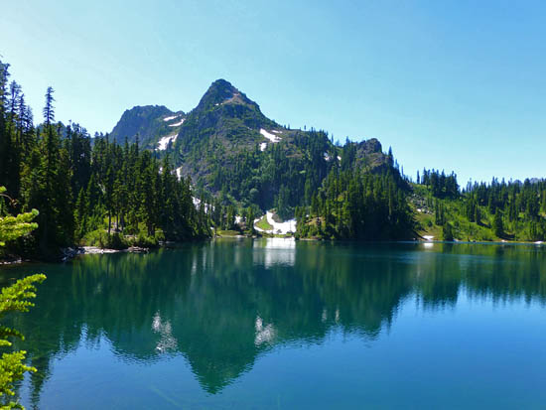
A Hike in the Olympics
When he was growing up, my father Ray spent most weekends on Hood Canal and hiking with his parents in the Olympic Mountains. Called “Mom” and “Pop” by everyone they knew, they developed a love of the outdoors in their son, who climbed every peak in the Olympics, and in their grandchildren, who have been avid hikers their entire lives.
Photograph by ProTrails
A favorite spot for Mom, Pop and Ray was Upper Lake Lena. Despite its popularity even then, they usually had the lake to themselves. (While the hike to Lower Lena is an easy one, the trek to Upper Lena is more challenging with steep, exposed switchbacks and almost 4,000 feet of elevation gain.) Over time and with their frequent visits, they created a semi-permanent campsite. It had a well-established path to the creek for fresh water, a campfire ring with large stones, and a raised area for sleeping where they erected tree trunk poles from which to string a tarp. They created a cache in a nearby rocky overhang with a metal box for the tarp, matches, dry kindling, a cast iron fry pan, some fishing gear, and a first aid kit.
The trips to the lake continued for many years for my dad and my grandfather, eventually including my brother, Dan. When I was ten, it was finally my turn to join the fun. Pop was 64 and Mom insisted he was getting too old to make the trek. Unwilling to give it up, he chartered a helicopter. It landed on our dock on Hood Canal and was loaded with most of the gear for our trip. Of course Pop made it to the lake well ahead of us and hiked halfway down the trail to meet us, relieving me of my little backpack for the final few miles of switchbacks. I can’t remember whether we told on him to Mom.
Several things stand out in my memory of that first trip. Waking up the first night with a huge moon overhead, sure my dad or my brother was playing a trick on me and shining a flashlight in my face. Finding the cache box safe and sound. Swimming in the cold water of the lake. Catching fish and frying them over the campfire. “Skiing” down a steep slope of shale fragments. The whistling of marmots standing erect on a hillside. The funny ponytail Ray invented for the top of my head to tame my hair. The smooth hiking stick Pop made to help me make it up Mt. Lena’s 5,995-foot elevation.
The week ended much too soon and we headed home. By the end of the seven miles down the trail, Dan and I were excited about reaching the car, racing ahead of Ray and Pop. Near the bottom I tripped and fell. Dan wiped my tears and the blood off my chin and helped me pick gravel out of my knees and palms while we waited for the others to make it to the trailhead. A funny side note — this past summer I hiked to Lower Lena with a friend and my dog. I got tangled in the leash, tripping and falling. No blood or gravel, but a sweet memory of my brother’s comfort.
Along with other hikes in the Olympics, Dan and I have both returned to Upper Lena over the years. It is much more crowded now so harder to remember the utter peace of our childhood adventures there, but it still retains the crisp mountain air, the blue green water of the lake, and that magical feeling of being up high in the Olympics.
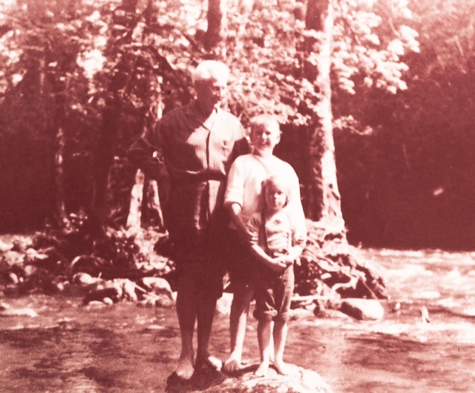

Dawn Smart
October 2016

